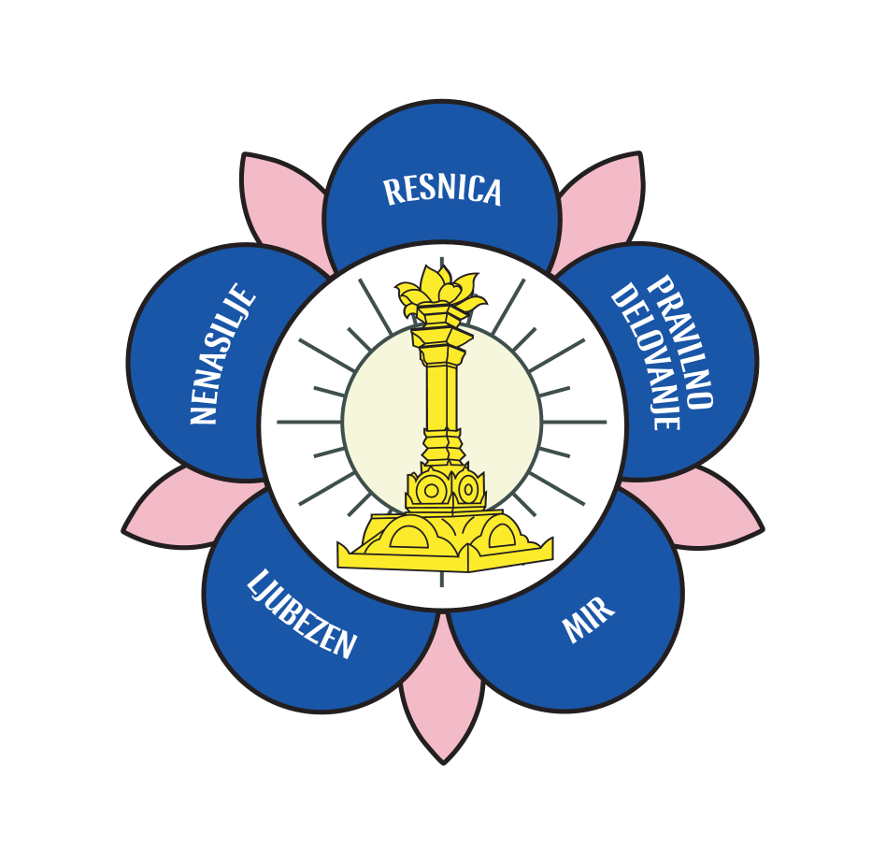
SPIRITUAL MEETING
SATHYA SAI ORGANISATION OF CROATIA AND SATHYA SAI ORGANISATION OF SLOVENIA
UNITY IS DIVINITY, PURITY IS ENLIGHTENMENT
Rovinj, 27.09.2019. – 29.09.2019.
(Centar M.A.R.E., Luigija Montija 2)

FRIDAY – 27.09.2019.

14:00 – 18:00 – ARRIVAL AND ACCOMMODATION
18:00 – DINNER
18:30 – 19:00 – WELCOME AND PROGRAM ANNOUNCEMENT
19:00 – 20:00 – INTRODUCTORY LECTURE: UNITY AND PURITY / ADRIANO BRATOVIĆ
20:00 – 21:00 – DEVOTIONAL SINGING/PRAYER/MEDITION

SATURDAY – 28.09.2019

6:30 – 8:00 – 21 x OMKAR, SUPRABATHAM (ENGLISH), 3 x GAYATRI MANTRA, 3 x SAI GAYATRI MANTRA, PRAYER, DEVOTIONAL SINGING
8:00 – 8:30 – MORNING EXCERSICES / YOGA
8:30 – 9:30 – BREAKFAST
9:30 – 11:00 – UNITY AND PURITY IN THOUGHTS, WORDS AND DEEDS/ GIOVANA KIRINIĆ, TANJA VOJNIĆ
11:00 – 12:00 – HOW TO DEVELOP VISION OF UNITY IN A DIVIDED WORLD? / SEVERIN TRIFUNOVIĆ
12:00 – 12:30 – BREAK FOR TEA NAD COFFEE
12:30 – 13:30 – SATHYA SAI ORGANISATION – DIVINE INSTRUMENT / DUBRAVKA SCHIFFMANN
13:30 –14:30 LUNCH
14:30-16:00 – FREE TIME
16:00 – 17:00 – ROLE OF OMKAR AND SUPRABATHAM / FERRY STEPANČIČ
17:00 – 18:00 – UNITY AND PURITY THROUGH GAMES / YOUNG ADULTS OF CROATIA AND SLOVENIA
18:00 –18:15 – SUMMARY OF THE DAY
18:30 – 19:30 – DEVOTIONAL SINGING / PRAYER / MEDITATION
19:30 – DINNER

SUNDAY – 29.09.2019

6:30 – 8:00 – 21 x OMKAR, SUPRABATHAM (ENGLISH), 3 x GAYATRI MANTRA, 3 x SAI GAYATRI MANTRA, PRAYER, DEVOTIONAL SINGING
8:00 – 8:30 – MORNING EXCERSICES / YOGA
8:30 – 9:30 – BREAKFAST
9:30 – 10:30 – REPEATING GOD'S NAME – UNIVERSAL SPIRITUAL DISCIPLINE / TINA GATALICA
10:30 – 11:30 – SYMBOLISM OF LIGHT AND MEDITATION ON LIGHT / SANJANA ZORINC
11:30 – 12:30 SUMMARY OF THE SPIRITUAL MEETING + QUESTIONS AND ANSWERS
13:00 – LUNCH
DEPARTURE

