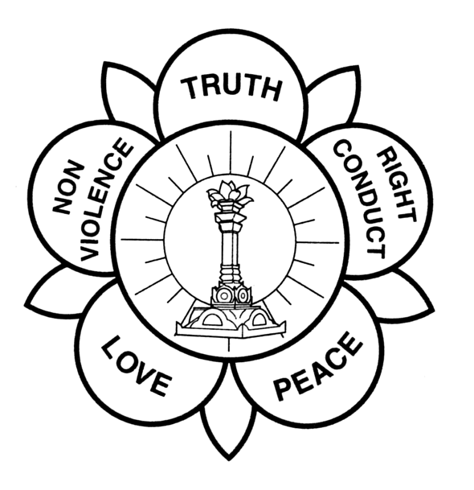

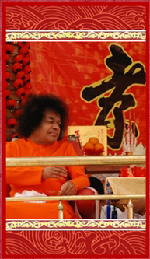

CHINESE NEW YEAR
CELEBRATION 2008
(In the Divine Presence of Bhagawan Sri Sathya Sai Baba)
Theme: “忠 孝” (Zhong Xiao)
“Cherish and Respect Our Motherland, Our Parents & Elders”

12 & 13 February 2008

dATE OF cELEBRATION
The first day of Chinese New Year (CNY) in 2008 falls on 7 February. The CNY celebration in the Divine Presence of Bhagawan Baba will be held in Prasanthi Nilayam on 12 & 13 February 2008 (Tuesday & Wednesday).

Theme of Event
The theme chosen for next year’s CNY event is “忠 孝”(“Zhong Xiao”) meaning ‘Cherish and Respect Our Motherland, Our Parents & Elders’. The Chinese word 忠 孝(“Zhong Xiao”) is a value that has resonates in our Chinese tradition and culture for over 5,000 years. This theme is also in line with Swami’s constant reminder in many of His Divine Discourses, that we should love our own motherland and respect and revere our parents and elders.
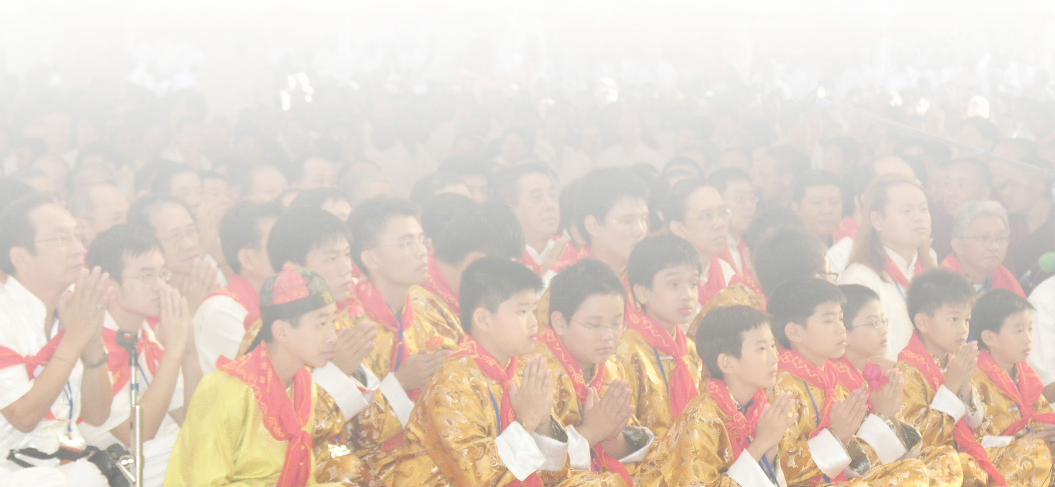
Objectives of Event
- To enable Chinese devotees throughout the world the opportunity of getting close divine darshan of Bhagawan Baba on the occasion of the celebration.

- To motivate all Chinese devotees to make a commitment to affirm the great values of Chinese Tradition, Religion and Culture as an ongoing process in their lives and as a dedication to the omnipresent SAI, His Vision and Mission.

PARTICIPANTS OF CELEBRATION
About 1,500 Chinese devotees from Malaysia, Singapore, Indonesia, Taiwan, Hongkong, mainland China and other countries is anticipated to participate in the programme.

HOW TO PARTICIPATE
All participants are required to register with the central Sai Baba organization in their respective countries using the attached registration form. Each participant will be given a special scarf for purposes of identity and special seating arrangement while in Puttaparthi. Deadline for registration 10th January 2008.

ACCOMODATION
Each country will arrange and handle with the Accommodation Office in Prashanti Nilayam for appropriate accommodation for their participants.

INTERNATIONAL CNY SECRETARIAT

- Sis Lai Houng Meng send2meng@yahoo.com 03-22744827

- Bro. Wong Weng Yam wywong@macrosoft.com.my 017-8887885

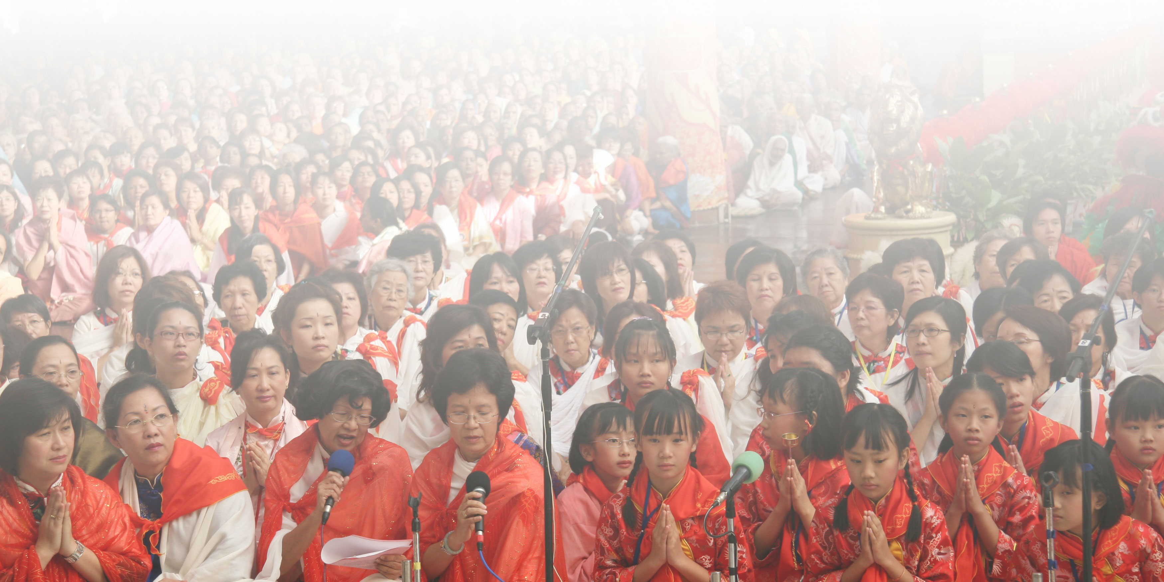
“Never take lightly the transformation that is taking place as I walk among you. All that My Eyes fall on will be transformed…. Rest assured that whatever My Eyes see becomes vitalized and sent transmuted. You are being changed day by day. Never underestimate what is being accomplished by this act of Darshan. My walking among you is a gift, yearned for by the Gods of Highest Heaven, and here you are receiving this Grace. Be grateful. These blessings you receive will express themselves in due time…” - Baba

Billy Fong – Coordinator
Chinese New Year Celebration 2008

